Sensus Access
Students can make alternative formats of documents including MP3 audio, Word, Braille, and e-books via Library Support web pages.

- Click link or copy and paste into web browser.
https://www.bristol.ac.uk/library/accessibility-support/alternative-formats/

- Scroll to bottom of the page to find the tool:

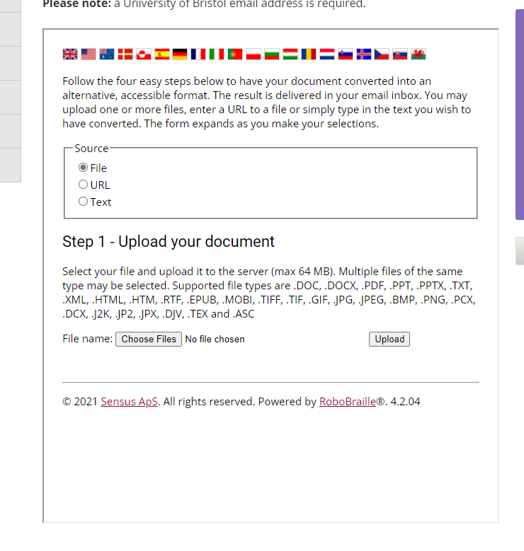
- Click ‘choose file’. This opens file finder:
- Find file and click open
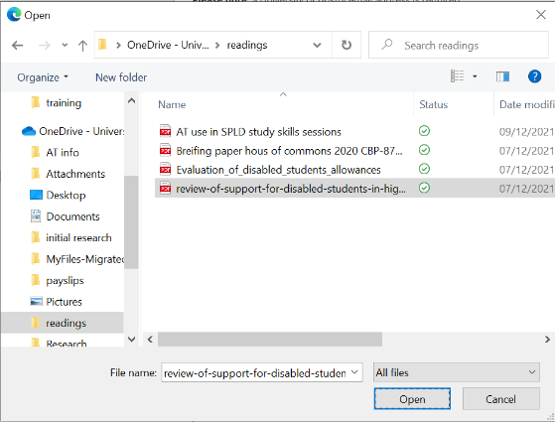

- Click upload
- Options appear of format – click format required
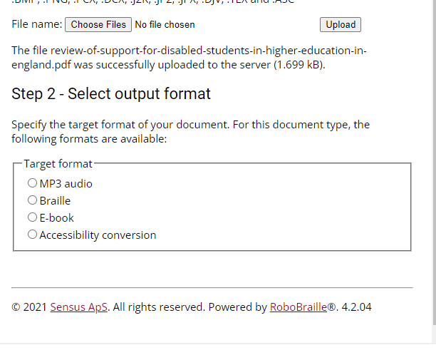

- Step 3 appears with more options:
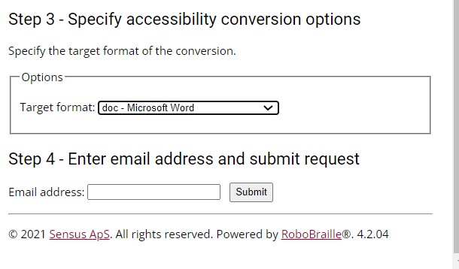

- Select required option and then enter university email address and click submit

For video of how to click here or copy and paste into web browser:
https://www.sensusaccess.com/resources/videos/

If you have any problems please contact Library Support on:
https://www.bristol.ac.uk/library/accessibility-support/library-support/#contacts

